Tackling family violence hindered by government structures – commission chair
Marcia Neave uses closing address at last of public hearings to call for change, saying she hopes hearings had ‘exposed the scale and effect of family violence.’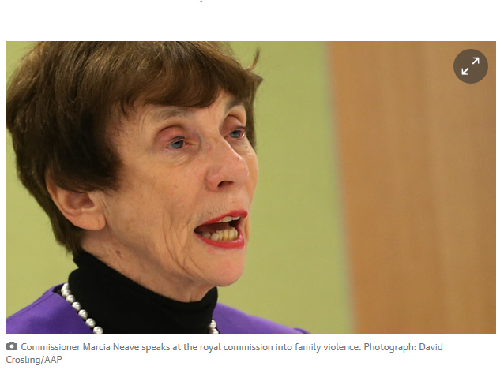
Commissioner Marcia Neave speaks at the royal commission into family violence. Photograph: David Crosling/AAP
The chair of Victoria’s royal commission into family violence has said the “structures of government” had in the past impeded responses to family violence and must change as the commission finished its fifth and final week of public hearings.
Marcia Neave said in her closing address on Friday: “There would be little point in making recommendations about these matters unless our recommendations were supported by changes to the structures of government which have, in the past, impeded effective responses to family violence.”

Ken Lay: female peers, not government, drove Victorian family violence change
Former police chief commissioner says he was driven to make cultural changes by ‘very strong women’s voices’ rather than by government and politicians
Read more
“We are grateful for the care and thought which witnesses brought to the difficult task of re-imagining a family violence system which could prevent the awful blight of family violence, keep victims safe and help those who use family violence to change their behaviour.”
Fifty-two witnesses, including Victoria’s former police chief commissioner Ken Lay, gave evidence to the commission this week about what the overall family violence system should look like, how it should be funded, and how it should be governed.
While the public hearings were initially scheduled to finish in August, the further week of hearings were held because the commission felt it needed more evidence about funding the family violence system, and training the family violence workforce.
In the past week, the possibility of establishing an independent agency to hold the overall family violence system to account was raised, as well as the ways government funding of programs and services sometimes impeded a better structured system.
Neave acknowledged victims of family violence who had given evidence before the commission, or who had followed the proceedings, which were streamed live online.
“We hope that our inquiry has helped to expose and explore the many issues experienced by people directly affected by family violence and those who work with them, in ways that acknowledge and affirm their experience,” Neave said.
“We also hope that it has exposed the scale and effect of family violence, and contributed to the community’s collective will to support significant improvements in preventing and responding to family violence.”
Commissioners heard evidence from 219 witnesses throughout the public hearings. The commission also held separate roundtables and private meetings with experts from the sector.
It will provide a set of recommendations to the Victorian government by March next year. The government has committed to adopting every recommendation made.
http://www.theguardian.com/australia-news/2015/oct/16/tackling-family-violence-hindered-by-government-structures-commission-chair

